Practical - 12
Practical Title: Event Management CRUD with Poster Upload and File Validation

Problem Definition : Develop event management functionality for admin users. Admin can add, view, update, delete, and upload event posters with file type and file size validation.

Theory
1. Are add, update, and delete functionalities implemented correctly? Yes, events can be added, updated, and deleted using PHP and MySQLi.

2. Is the UI linked with the database correctly? Yes, the UI is connected to the MySQL database using MySQLi, and event details are stored and retrieved from the database.

3. Are poster uploads validated for type and size? Yes, only JPG, PNG, and WEBP images are allowed, with a maximum file size of 2 MB.

4. Are success and failure messages displayed? Yes, success messages are displayed after adding, updating, or deleting an event, and error messages are displayed when an operation fails.

A. Evidence of Work (Screenshots):
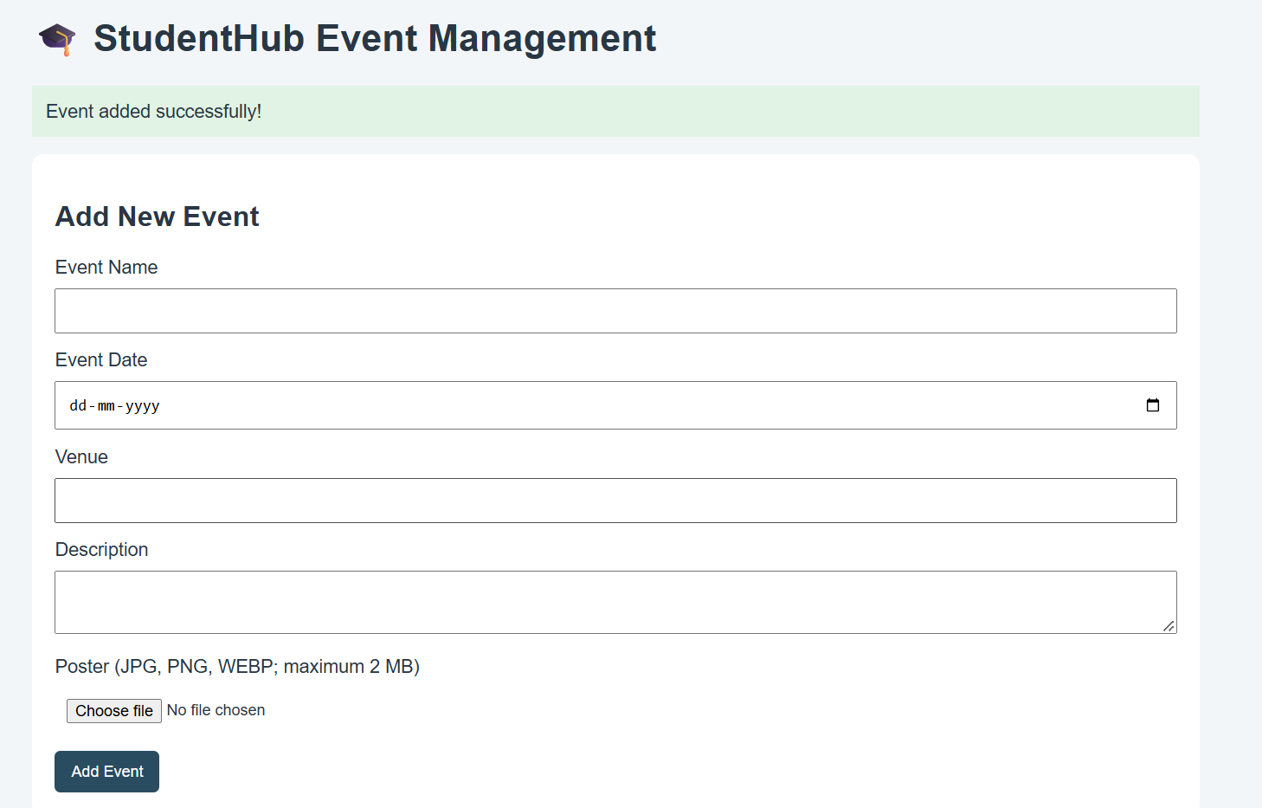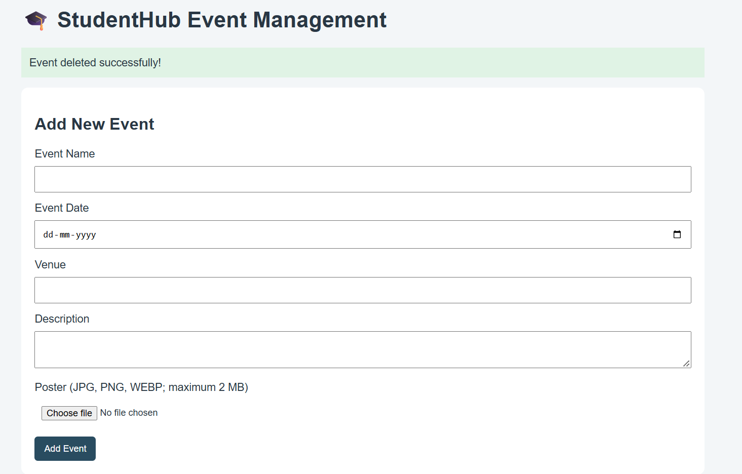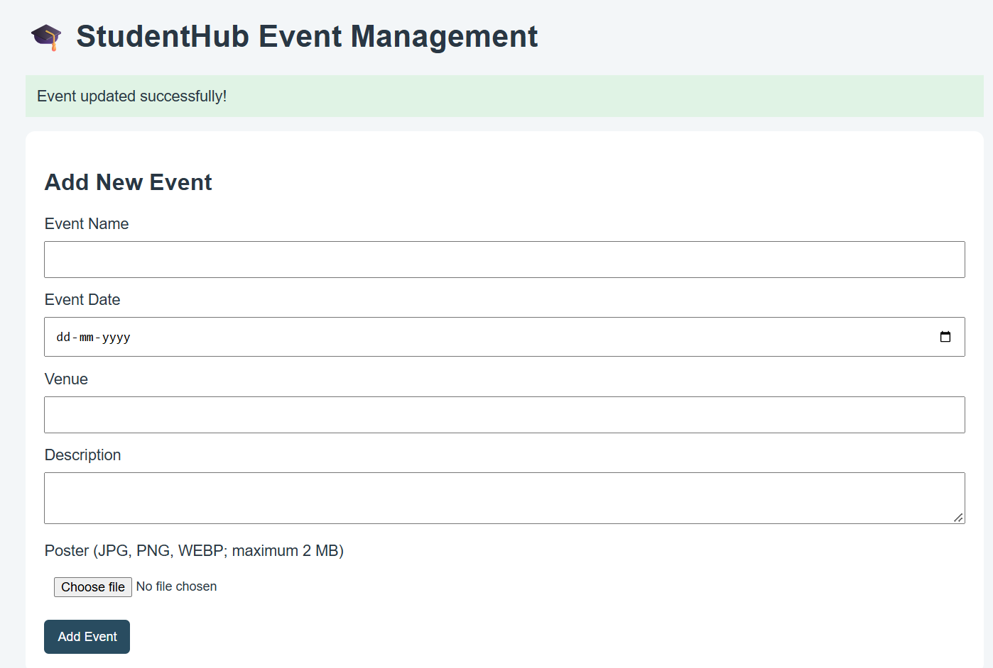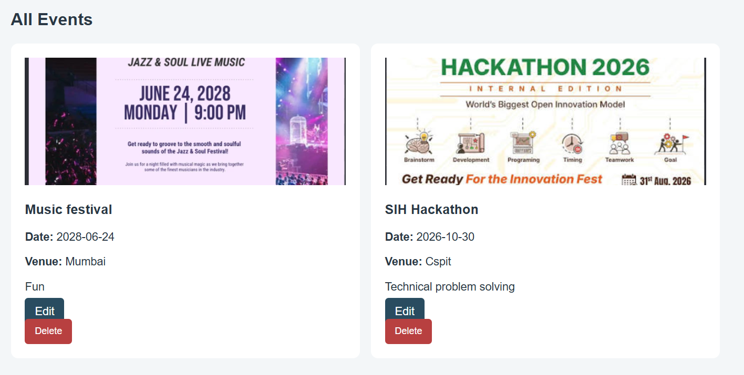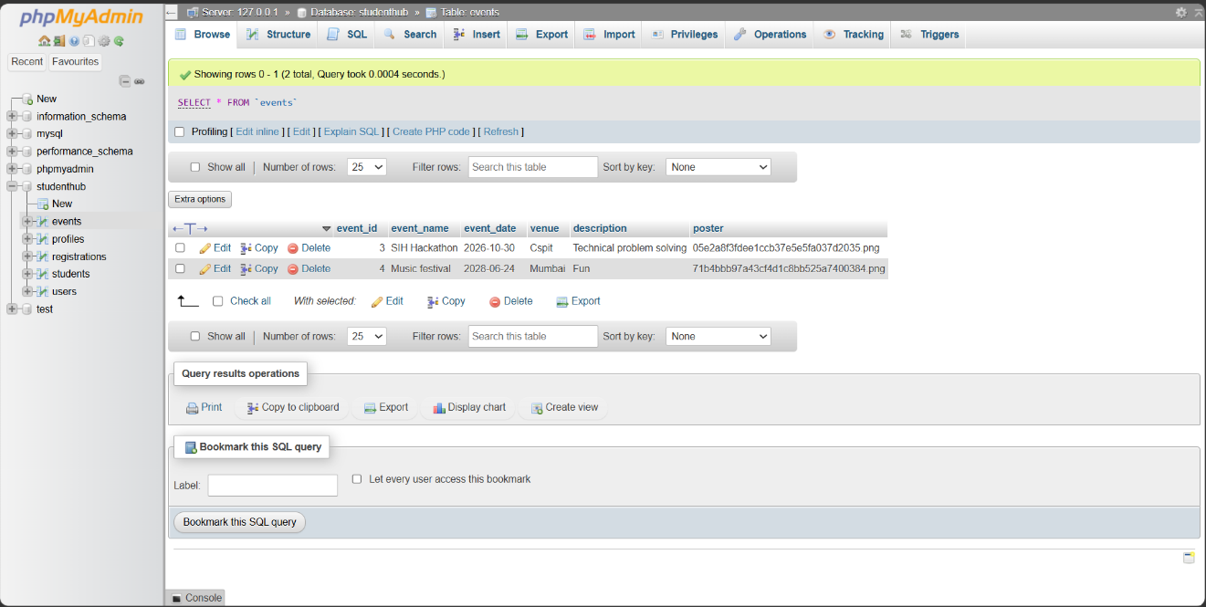
B.GitHub Repository Link:
https://github.com/Andarpadhruvi1125/Student-Hub-portal.git
C. Challenges Faced
During this practical, I faced challenges in connecting PHP with the MySQL database and correcting column name errors. I also learned how to handle poster uploads, validate file types and file sizes, and solve database errors while implementing add, update, delete, and view operations.
D.Learning Outcomes
Through this practical, I learned how to implement CRUD operations using PHP and MySQLi. I understood how to connect the user interface with the database, upload event posters securely with file validation, and display success and error messages.

Faculty Remarks:

